SOP for door to door delivery of essential goods and LPG.

Contents
(April 2020)
- Objectives………………………………………………………………......……...….…..3
- Risk and challenges………………………….…………………………....……...…….….3
- Door to Door Delivery Services:- Essential Goods..........................................................3-6
- Door to Door Delivery Services:- LPG...............................................................................6
- Zoning and Area of Coverage............................................................................................7
- Measures……………………………………………………………………..…….…...7-8
- Market Monitoring and Surveillance……………….….................................................9-10
- Facilitation of import and identification of essential goods...............................................10
- Supply Chain / flow of essential goods and LPG.........................................................11-12

- Objectives
This SOP should be adopted:
- To facilitate seamless supply of essential commodities and LPG in the event of partial or total lock down.

- Facilitate door to door delivery of essential commodities including LPG to the consumer/user without any hindrance.

- Coordinate with major wholesalers (TCC, FCB, UT Traders and Jimmy Commercial) and other traders to ascertain continuous supply chain, and

- Coordinate with Dzongkhag, Thromde, Dungkhag, Gewog and relevant sectors for necessary support to ensure un-disrupt supply and smooth operation of this SOP.

Risk assessment/ unforeseen challenges
The following are some of the risks identified during the imposition international border seal and lockdown in the region:
- Disruption of supply chain
- Travel restriction; and
- Closure of shops (Government Notification/Circular) or not able to open shops upon movement restrictions.
- Partial Lockdown
Partial lock down means not imposing completed restriction on the movement of the people and vehicles. Following measures or strategies shall be adopted:
Measures:
In the event of partial lock down, following strategies shall be implemented:
Opening and Closing down Business:
During the partial lock down, only identified wholesalers, retailers and pharmaceutical shops shall remain open. Rest of the shops or business establishments shall remain closed.However, the business/shops will remain open from 8 am - 5pm for business.
Identified Wholesalers/retailers and Pharmaceutical shops:

Sl # | Name of Shop | Location | Contact No | GPS integration | Accessibility to Customer
1 | Surendar Grocery | TLT Hotel Building | 17616021 | Yes | Yes
 | Seldon Grocery | Seldon Building | 77274577 | Yes | Yes
3 | Yargay Store | Opposite to Seldon Grocery | 17647294 | Yes | Yes
4 | Lhaki Pharmacy | Dasho Thrompon Building | 17630454 | Yes | Yes
5 | Namgyel Tshongkhang | Adjacent to TCC | 17121211 | Yes | Yes
6 | Baijnath Lalu Gupta & Sons | Opposite to Baijnath Hardware | 17610144 | Yes | Yes
7 | Dendup Mart | Opposite to Hotel Friends | 17691818 | Yes | Yes
8 | Kezang Tshongkhang | Lower Market | 17118221 | Yes | Yes
9 | Pema Dejung Bumzang Tshongkhang | Lower Market | 17813722 | Yes | Yes
10 | Namgayling Mart | Ground Floor of T-bank | 17635151 | Yes | Yes
11 | Sonam Tshongkhang | Infront of YDF hostel | 17697936 | Yes | Yes
12 | Lhundup Tshongkhang | Opposite SJ MSS gate | 17533714 | Yes | Yes
13 | Chenga Dawa Tshongkhang | Dawa Building, Upper market | 17433560 | Yes | Yes
14 | Natshog Lhaden Tshongkhang | Thinley Building | 77277477 | Yes | Yes
15 | Phunsum Bar & General Shop | Lungtuck Building | 17363200/77422913 | Yes | Yes
16 | Kezang Store | Deothang (near RBA camp) | 17503856 | Yes | Yes

- Total (Complete) Lockdown
- Door to door delivery services:- Identification of shops
3.1. For Essential Commodities:-
Those shops identified for door to door delivery of essential commodities in the event of prtial or complete lock down are:
- Under Samdrup Jongkhar Dzongkhag
Waiting for list of identified shops from Gewogs

- PemaGatshel Dzongkhag:-
Total of 20 shops have been identified in consultation with and support from Dzongkhag, Dungkhag and Gewog.
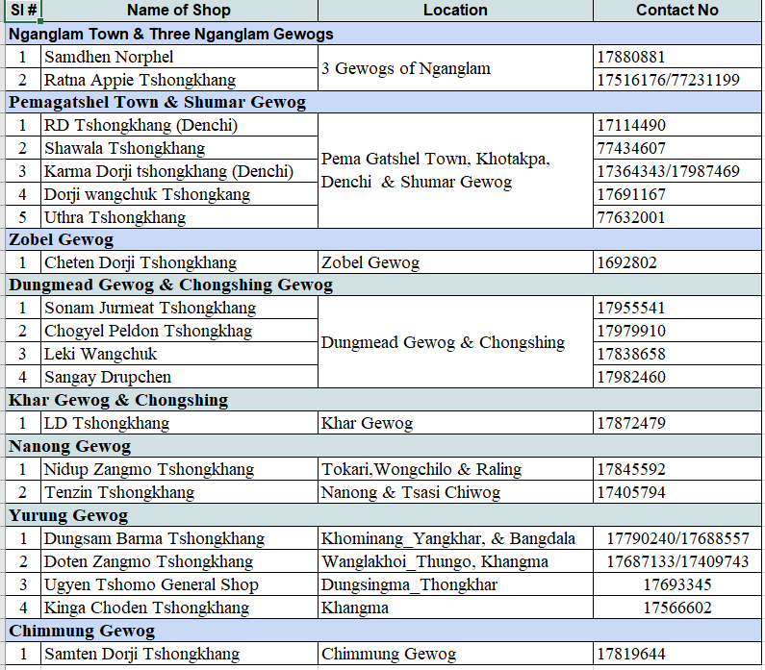
  - Major Stock piling Shops:
Apart from above, following shops/distributors are identified by MoEA for stocking of essential items for six months.
Sl # | Name of Agent | Warehouse location | Items | Contact #
1 | FCB | S/Jongkhar, N/Lam, S/Choling, Jomotshangkha, P/Gatshel | Rice, Oil & Pulses | RM-17610315  Manager-
2 | Tashi Commercial Corporation | S/Jongkhar | 16 essential items | Manager: 77251607; Asst. Manager: 77300003
3 | UT Trader | S/Jongkhar | 16 essential items including rice & oil | Manager: 77225062
4 | Jimmy Commercials | S/Jongkhar & Nganglam | 16 essential items including rice & oil | Manager: 16485150
5 | Chhayang Enterprise | Nganglam town | 16 essential items including rice & oil | Proprietor: 77746223
6 | Tashi Delek Tshongkhang | Jomotshangkha Town | 16 essential items including rice & oil | Proprietor: 17778426
Above identified distributors/wholesalers/retailers are the main supply source for the other retailers as well consumer during the lock down.
  - Other Major Traders
In addition, the following wholesalers or retailers are also identified as back up to ensure continuous supply of goods. Administrative and logistic supports are extended to these establishments in terms of continuous and smooth transit of goods from the source :
Sl # | Name of shop | Location | Items | Contact #
Samdrup Jongkhar Town
1 | Namgyel Tshongkhang | Lower Town | 16 essential items including rice, oil & pulses | 17121211
2 | Kezang Store | Lower Town |  | 17118221
3 | Surender Grocery | Lower Town |  | 17616021
4 | Saha Brothers | Lower Town |  | 17744080
5 | Namgay Tshongkhang | Lower Town |  | 17119959
6 | Pema Dejung Bumzang Tshongkhang | Lower Town |  | 17813722
7 | Baijnath Lalu Gupta & Sons | Lower Town |  | 17610144
8 | Natshog Lhaden | Upper Town |  | 77277477
Pemagatshel Town
1 | RD Tshongkhang | Denchi | 16 essential items including rice, oil & pulses | 17114490
2 | Cheten Tshongkhang | Zobel, Kheregoenpa |  | 17364343/17987469
3 | KD Tshongkhang | Denchi |  | 17364343/17987469

For LPG:-
4.1. Identified Dealers/agents for the door to door delivery of LPG:-

SN | Name | Location | Contact No | Zoning
1 | BOD | Samdrup Jongkhar
2 | DPCL | Samdrup Jongkhar
3 | BOC | Jomotshangkha
4 | BOC | Samdrupcholing
5 | BOC | Pemagatshel
6 | BOC | Nganglam
7 | FMCL | Dungmaed
8 | FMCL
9 | FMCL | Samrang
10 | FMCL | Lauri
11 | Karma Cheki LPG Agent | Dewathang
12 | LPG agent (private) | Gomdar

- Zoning or Identification of area of Coverage for delivery services:-

RTIO in consultation with Dzongkhag, Thromde, Dungkhag and Gewog shall adopt the best possible strategy to identify the area of coverage. Those identified shopkeepers shall be notified about their respective area of coverage with the objectives to cover as many as possible leaving not a single household out.
As per the statistics maintained by two dzongkhags namely Pemagatshel and Samdrup Jongkhar there are 4825 and 4349 number of households with total population of 37,187 and 29,574 respectively and while 8,609 people residing in Samdrup Jongkhar Thromde.
Samdrup Jongkhar Dzongkhag |  |  |  | Pemagatshel Dzongkhag
Gewog | Households | Population |  | Gewog | Households | Population
Deothang | 336 | 2592 |  | Chimung | 204 | 1760
Orong | 540 | 5255 |  | Chongshing | 222 | 2287
Gomdar | 611 | 5018 |  | Dungmin | 352 | 1271
Wangphu | 430 | 3397 |  | Khar | 453 | 3960
Phuntshothang | 725 | 4689 |  | Nanong | 326 | 4750
Pemathang | 448 | 2819 |  | Shumar | 690 | 5890
Martshalla | 501 | 4116 |  | Yurung | 402 | 2742
Samrang | 32 | 402 |  | Zobel | 448 | 1,696
Lauri | 545 | 4601 |  | Chokhorling | 270 | 2170
Serthi | 373 | 2353 |  | Norbugang | 392 | 1368
Langchenphu | 284 | 1945 |  | Decheling | 590 | 1680
Total | 4825 | 37187 |  | Total | 4349 | 29,574
Samdrup Jongkhar Thromde
Population |  |  |  |  |  | 8609
Request Thromde to provide us total household numbers

Tracking of shop:- GPS
To enable the consumer to easy locate the shop, all shops identified above will be very soon registered in GPS (Global Positioning System) so that consumer using their phone can easy locate the shops and contact details of the shop online. Total of 14 shops under Samdrup Jongkhar including major players such as FCB, TCC and UT are in the list.
Shops Identified for GPS
Sl # | Name of Shop | Location | Activity | Contact No
1 | Surendar Grocery | TLT Hotel Building | Grocery | 17616021
2 | Drangtshen Tshongkhang | Lotay Building, Lower Market | Grocery | 17614561
3 | Seldon Grocery | Seldon Building,Lower Market | Grocery | 77274577
4 | Yargay Store | Opposite to Seldon Grocery | Grocery | 17647294
5 | Lhaki Pharmacy | Dasho Thrompon Building | Pharmacy/Medical Store | 17630454
6 | Namgyel Tshongkhang | Adjacent to TCC | Grocery | 17121211
7 | Baijnath Lalu Gupta & Sons | Opposite to Baijnath Hardware | Grocery | 17610144
8 | Dendup Mart | Opposit to Hotel Friends Hotel | Grocery | 17691818
9 | Kezang Store | Lower Market | Grocery | 17118221
10 | Pema Dejung Bumzang Tshongkhang | Lower Market | Grocery | 17813722
11 | Saha Brothers | Lower Market | Grocery | 17744080
12 | Namgayling Mart | Ground Floor of T-bank | Grocery | 17635151
13 | Sonam Tshongkhang | Infront of YDF hostle | Grocery | 17697936
14 | Lhundup Tshongkhang | Near NPPF colony entry gate | Grocery | 17533714
15 | Chenga Dawa Tshongkhang | Dawa Building, Upper market | Grocery | 17433560
16 | Natshog Lhaden Tshongkhang | Thinley Building, upper Market | Grocery | 77277477
17 | Phunsum Bar & General Shop | Lungtuck Building | Grocery | 17363200/77422913
18 | Tshering Ugyen Tshong | Adm Building, Upper market | Grocery | 17773585
19 | Kezang Store | Deothang (near RBA camp) | Grocery | 17503856
20 | FCB | Near Dzong | Storage
21 | TCC | Town | Storage
22 | UT Trading | Town | Storage
23 | Jimmy Commercial | DoR/Audit Building | Storage

For Example of zoning:

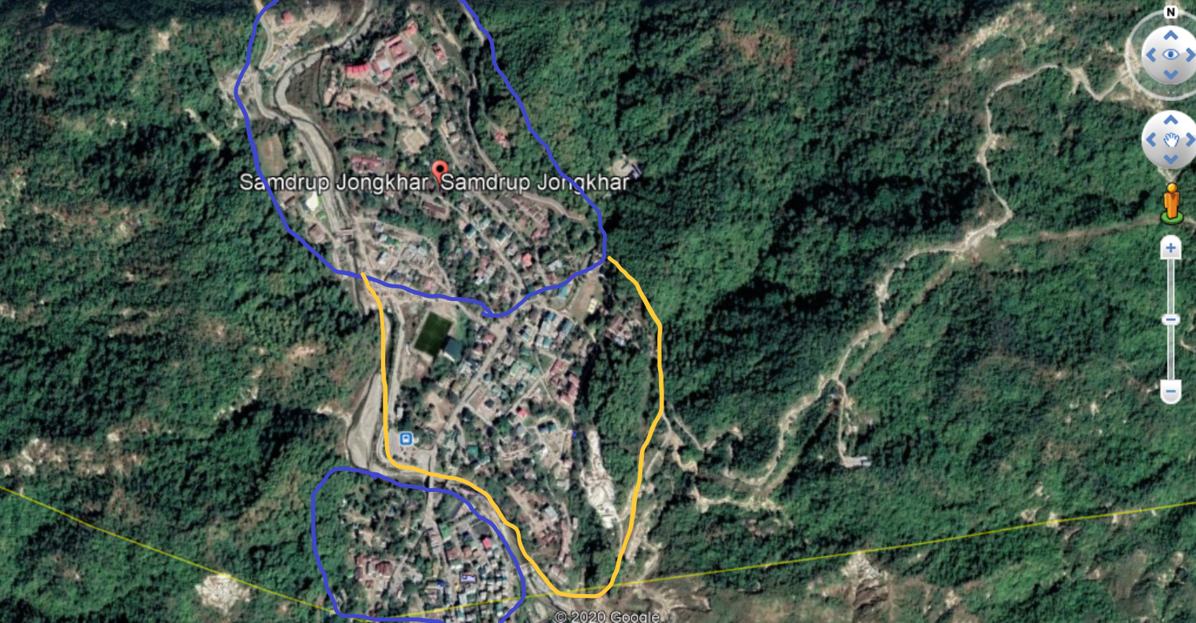

Measures:
To ensure continuous supply of goods within the region, following measures will be adopted:
6.1 Throm/Dzongkhag and Drungkhag Town:
- RTIO will identify the source for continuous supply of essential commodities and LPG and seek support from Dzongkhag, Dunkhag, Throm and Gewog for smooth and un interrupted supply of goods and LPG..
- Ensure essential commodities including LPG cylinders are delivered at the door steps adhering to the SOPs in place by those identified dealers or shops in their designated area. They will use only registered vehicles and person(s) for the purpose.
- The contact number of identified shops will be shared through local TV channels, Thromde Thuemi and Town/BCCI representatives. Support from respective LGs will be sought to disseminate information
- Use social media or call facilities for placing orders from the customer with proper delivery address or point of dropping
- While encouraging digital payment system, the dealers may accept cash down payment for some exceptional cases or find best solution of payment system to ensure safety
- Issue money receipts on all the items supplied or sold during services of door to door delivery
- The commodities order should be left at the door or agreed point of drop. Its consumers duty to get it disinfected and follow safety protocols
- For LPG, the dealers identified should adhere to its SOP and maximum sanctioned will be only 10 cylinders (both subsidized and unsubsidized). The agent must ensure all records such as consumer ID, CID and contact details are maintained and submitted to RTIO for sanctioning of the next quota. The submission and sanctioning of quota will be through use of social media.
6.2 Gewogs and Chiwogs:-
- Respective Gewog administration in line with Dzongkhag contingency plan, other SOPs will identify the shop (s) for door to door delivery considering the proximity of shop and community. However, all gewog should submit the list of identified shops for door to door delivery of essential items in the Gewog and chiwogs. In addition, compile and submit the list of those shops to be remained open during lock down to RTIO.
- To ensure continuous supply of three major essential items, FCB to fully operationlize existing farm shops for stockpiling and explore best stocking or supply options in consultation with Gewog administration for those gewog without farm shops
- Those identified major stockpiling agents and traders in the Dzongkhag or Drungkhag will ensure continuous and seamless supply of 16 listed essential commodities to those shops identified for door to door delivery in the Gewogs and Chiwogs. The respective shop must discuss and agree the mode of supply and appraise COVID-19 Task Force accordingly for necessary logistic support.
- Door to door delivery of essential commodities including LPG for gewogs will be in line to Gewog COVID-19 contingency plan or set of protocols in place developed for the purpose.
In addition:-

- Agencies or persons should deliver LPG with correct weight- which should be min 29 Kg.
- Both identified agency(ies) and consumers shall take extra care to ascertain that LPG cylinders should not be damaged while loading or unloading.
- Consumers are advised to check for the expiry of the LPG on the neck of the cylinder and any suspicion should be reported to RTIO for appropriate action.

Quantity of essential items and LPG to consumer:

Call for suggestion and recommendation – Essential Goods

Only one LPg per house / month (subsidized)
Non-subsidized no restriction on quantity.
Coordination & Safety
- Control room shall be responsible to gather real-time information and disseminate to relevant sectors for necessary support and coordination.
- The hospitals in the Dzongkhag and Thromde shall be responsible to ensure door to door delivery agents adhere to safety protocols. For Gewogs, Gup in coordination with respective health units to ensure proper safety measures are followed.
- BAFRA shall be responsible for monitoring food safety measures including expiry of goods
- RSTA and RBP to facilitate smooth transit of goods from point of pick-up till dropping but monitor on ilegal transit of goods
- RTIO shall be responsible for coordination of supply of essential goods from major wholesalers or traders to door to door delivery
- Market Surveillance & monitoring during the lockdown
To ensure market prices are controlled and monitored regularly, the door to door delivery agents, will ensure adherence to following measures:
- Mandatory issuance money receipts and maintain counterfoil with them for verification
- Delivery agent to maintain records of purchase invoices and other cost incurred receipts
- Avoid dealing in expired, damaged or contaminated goods
For better monitoring and to increase the market surveillance, under mentioned strategy will be adopted with support from Local Government administrations:
Agency | Monitoring area | Complain reporting
RTIO | S/Jongkhar & Deothang town
P/Gatshel (EDO) | Pemagatshel & Denchi town | Forward serious offenses or unresolved issues to RTIO with sufficient evidences
Drungkhag Administrations | Respective Drungkhag town | -do-
Gewog Administrations | Respective Gewog | -do-

The market surveillance and monitoring committees constitute in respective LGs to function as per the SOP developed and circulated by Office of Consumer Protection, MoEA.

Facilitation of Import/supply of essential goods:
To ensure continuous and seamless supply of essential goods in the country during travel restriction, border seal and lock down, the Dzongkhag Task Force, RTIO, Samdrup Jongkhar and RSTA will facilitate smooth movement/transit of vehicles carrying essential commodities. However, all relevant SOP for safety protocols should be followed strictly.
RSTA will continue to issue road permits if need be to enable smooth transit of essential items both intra and inter Dzongkhag in addition to the present mandate of facilitating imports.

8.1. Transportation/Mode of delivery:-

To ensure smooth delivery service, transport/ delivery of goods and LPG to consumer is of a paramount important :-

Essential Commodities:

- Dzongkhag,Thromde, Drungkhag and Gewog shall support in identifying delivery agents and modes of transportation.

LPG:-

- Dzongkhag,Thromde, Dungkhag and Gewog will support in identifying delivery agents and modes of transportation.

- Supply chain/ flow of essential goods and LPG.
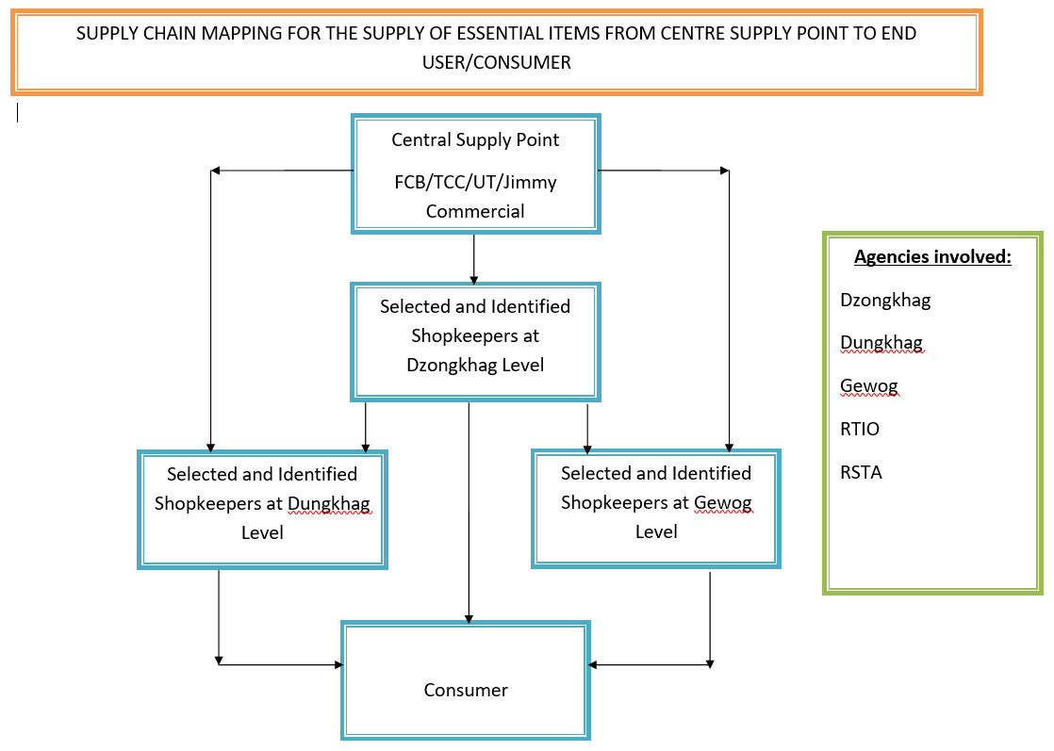

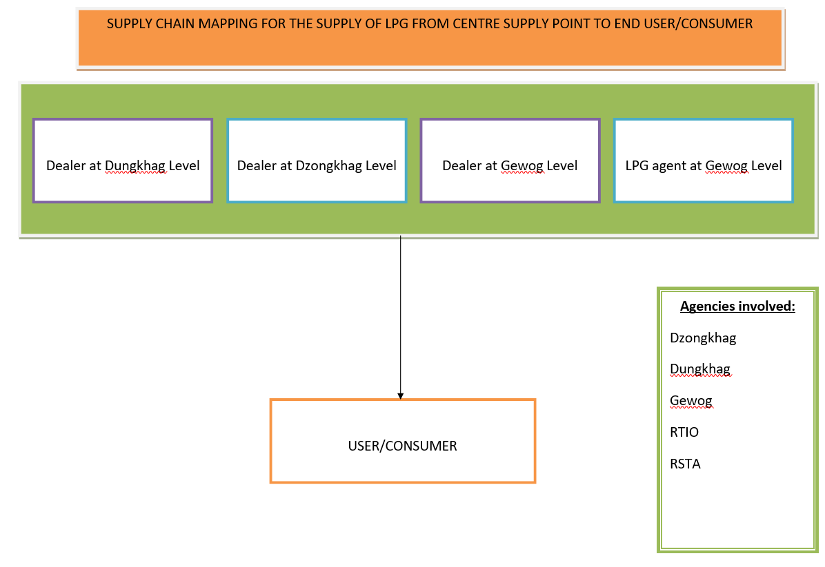

This SOP is a live document and is subject to partial or full amendment based on the situation and need.

